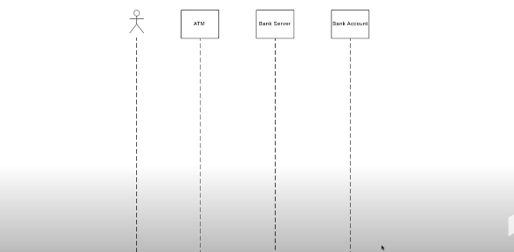***External Event :***

Actor someone who start process

***Example ATM***

User Input Card ………………..ATM…………….Atm Machine ………………………Banker

(Actor) (object) (object) (object)

**Notation :**

Actor by Stick figure :

**Rectangle :** Objects

**Lifeline :** are the vertical line in the system to show the existence of actor and objects

**Notation :**

……………………………………………….

When go to the bank first insert card it show an message

**Message : That Send By User to the Server**

**Return message :** message return by the server verification if password is right it go and if not send a message back

Notation : ………. Arrow …………………………>

Alternative Frame : Choice between two message if card valid or not give message

Card valid : we use a long rectangle for it

Card not valid : same here

Activation Boxes : How long process are perform we draw a long reactangle line

